**2.Design a user interface prototype for a mobile station using Figma, considering connectivity and convenience.**

**Aim: -**

To create a user interface prototype for a mobile station using Figma, considering connectivity and convenience.

**Procedure: -**

1. open Figma

2. Create a new file

3. Select the Frames

4. Design Visual Elements

5. Make it Interactive

6. Add icons on the Frame

7. Incorporate Multimedia

8. Storyboard Animation

9. Review and edit the Prototype

10. Save and Share

**Design:-**

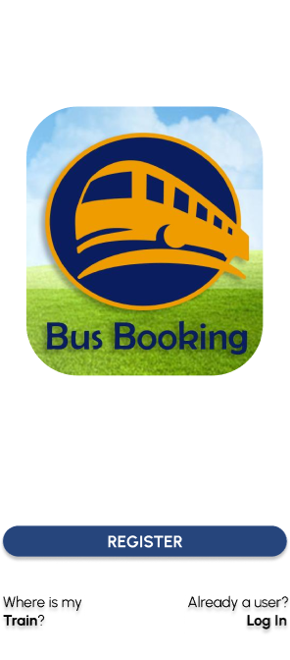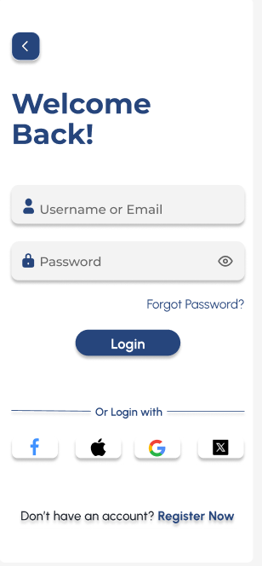

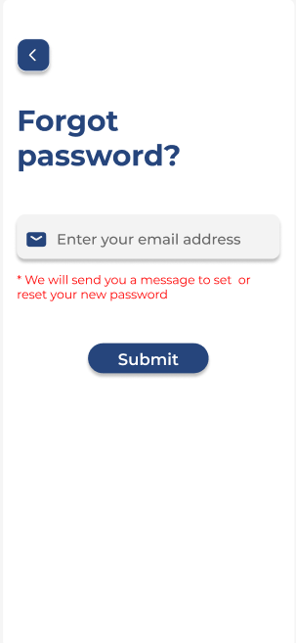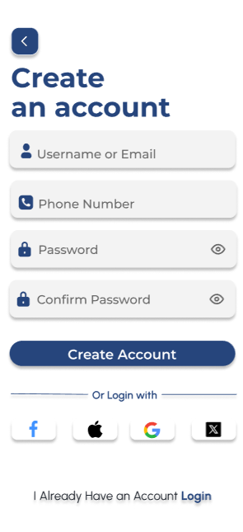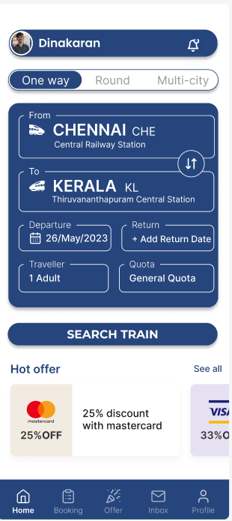

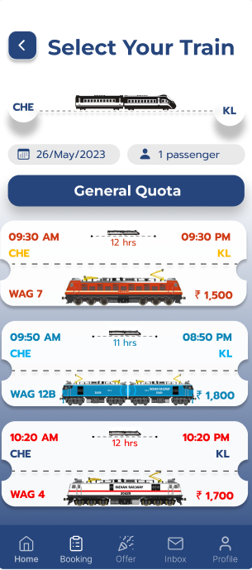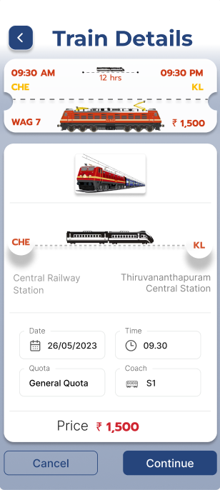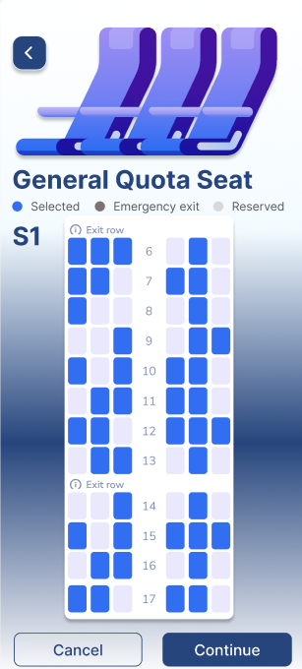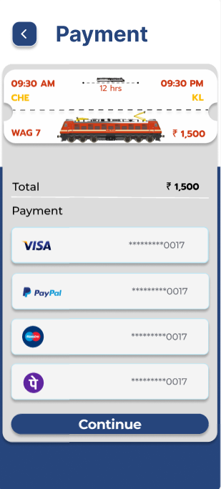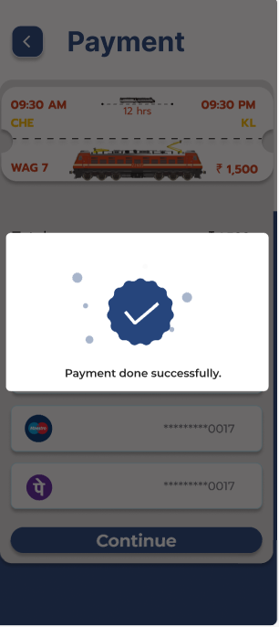

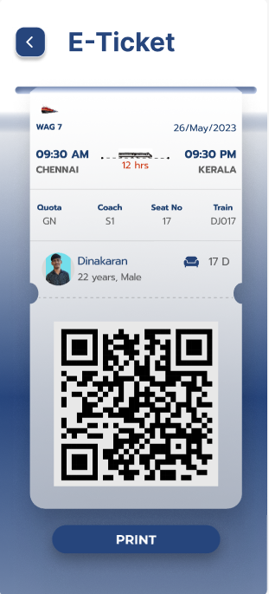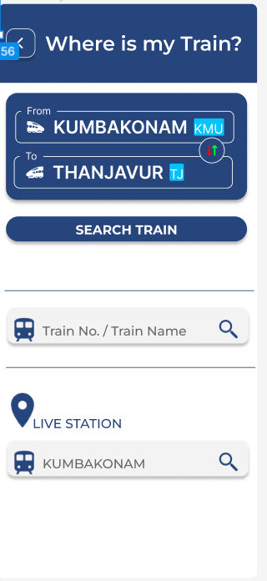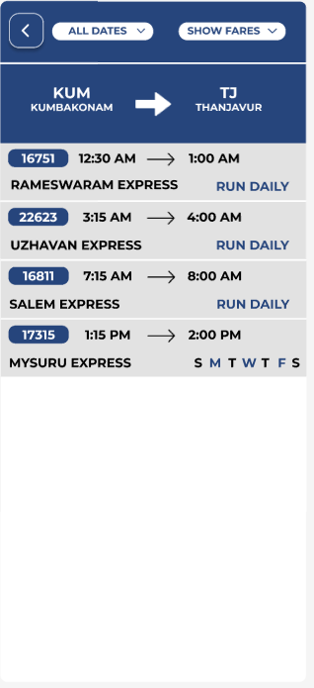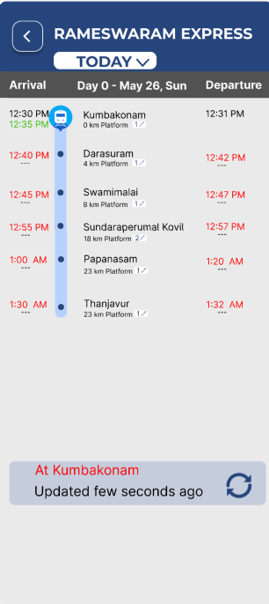

**Prototype: -**

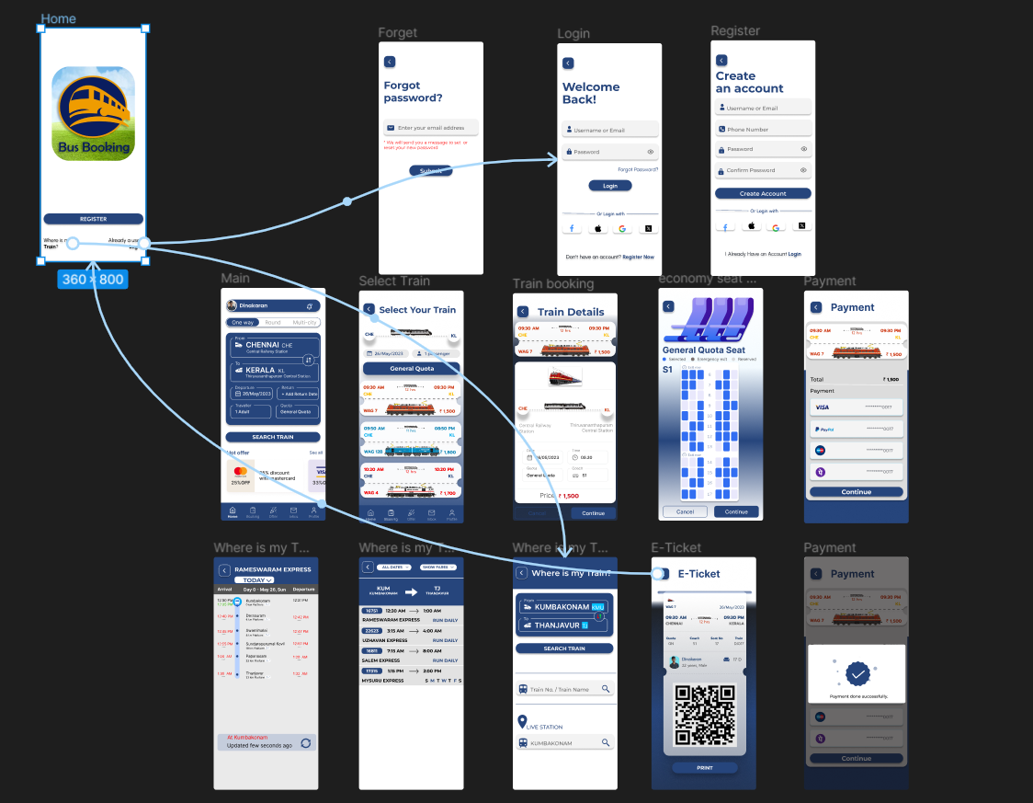

**Result: -**

A user interface prototype for a mobile station using Figma, considering connectivity and convenience using Figma is created and executed successful